HYBRID WILDERNESS FIRST RESPONDER RECERTIFICATION (HWRR)

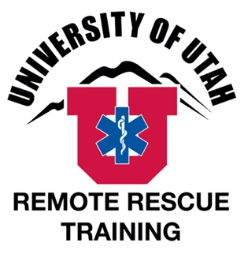
Sponsored by The University of Utah, Center for Emergency Programs, Remote Rescue Training & NOLS Wilderness Medicine

Dates: April 10-11, 2021
Cost: $365 Tuition only
Location: 270 South 1400 East, Salt Lake City, UT

Travel, Meals, and Lodging
Meals and Lodging
There is not a meal and lodging package available for this course. Salt Lake City has many hotels with prices in all budgets. The U of U Guest House (www.guesthouse.utah.edu/ or 801-587-1000) is walking distance from the classroom and provides the most convenient lodging. Any hotel in Salt Lake City near the University Trax line will make for an easy commute. There is no camping within the area of the course.

There are a several options for lunches within easy walking distance on campus, or we recommend that you bring a lunch.

Travel
The course will meet in room 113 (or 114, we cannot schedule far in advance but the rooms are right around the corner from each other), William Stewart Building, at the University of Utah, Salt Lake City Campus (270 South 1400 East, Salt Lake City, UT 84112). The Stewart Building is between President’s Circle and the football stadium on the U of U campus. Campus is ~15 minutes from I-15 or I-80, although traffic may cause delays during rush hour.

Go to https://map.utah.edu for a campus map. Use the drop-down menus at the top to search for the Stewart Building and to show parking areas.

Parking on campus on weekdays requires a parking permit. Permits may be purchased ahead of time online at https://commuterservices.utah.edu/campus-parking/. “U” permits cost $10/day and a “U” lot is located at the stadium.

Weekend parking is free. Parking in President’s Circle or the Law School is allowed.

Train service is provided near the Stewart building- Stadium Station- via Trax (www.rideuta.com/). The Utah Transit Authority also has regular bus service to the University of Utah.

Occasionally events on campus can complicate travel, parking or other logistics. We are not aware of any at this time.

Registration
How to Register
NOLS is collecting tuition and enrollment information for this course. Please register on the NOLS website.

Cancelation Policies
NOLS is taking all registration for this course. Please visit their policies page for an overview of cancelation and transfer policies.

For Questions about location and logistics, contact:
University of Utah, Center for Emergency Programs (UUCEP):
Office: (801) 581-4512
Websites: www.UUCEP.org
www.RemoteRescueTraining.com
Email: UUCEP@utah.edu
Rescue@utah.edu

For Questions about registration, contact:
NOLS Wilderness Medicine:
Office Hours: M-F from 8am-5pm MST
Phone: (866) 831-9001
wilderness_medicine@nols.edu
www.nols.edu/wilderness-medicine

